To: The record

From: Don Bellenger

Subj: CF Builder Setup after Installation

Date: October 8, 2013

Server is

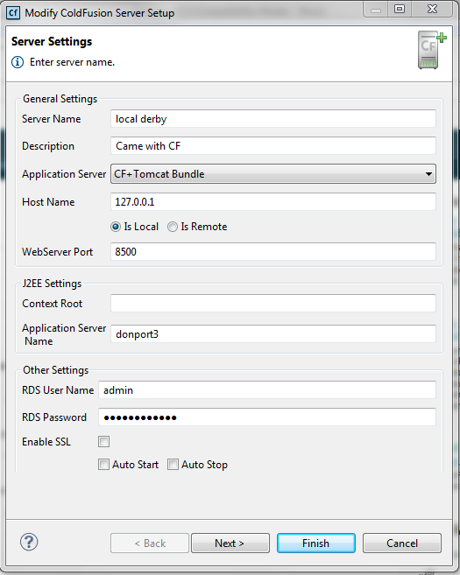

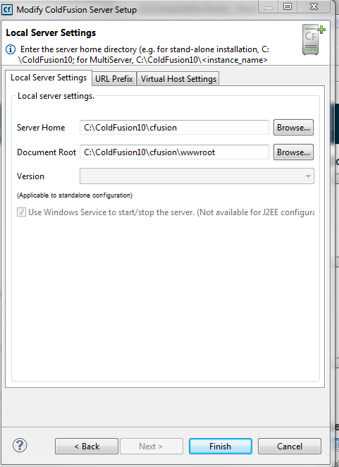

Then download ColdBox Bundle and extract, 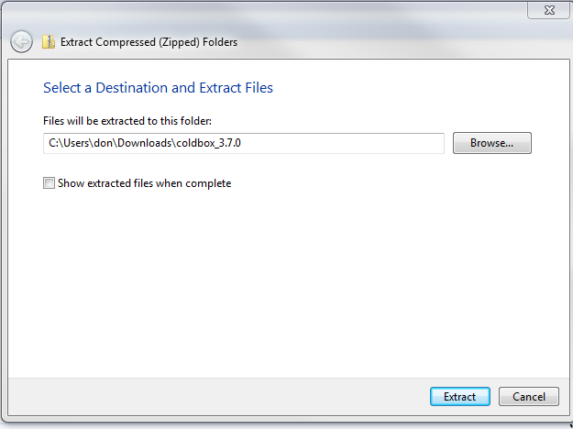

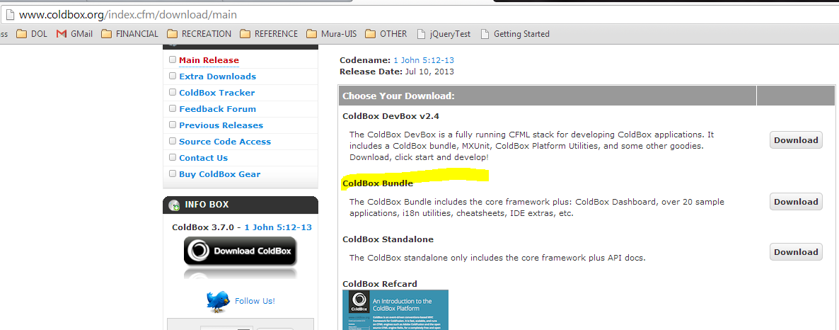

Extracted files are…

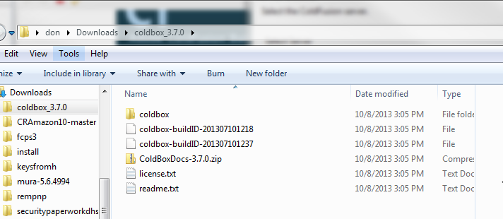

Per the readme.txt, move the coldbox directory to c:/…cfusion/wwwroot/coldbox.

Then click Project, New Project, enter name, and make new folder WITHIN the CB “New ColdFusion Project screen”

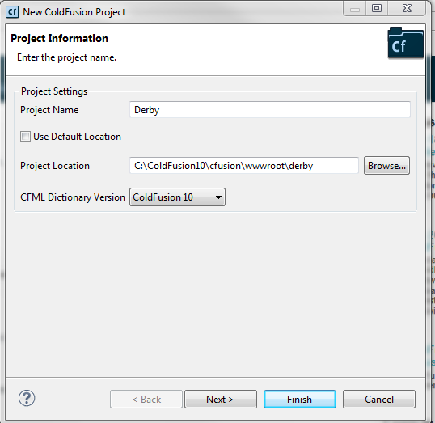

Select Server, and get location of Chrome

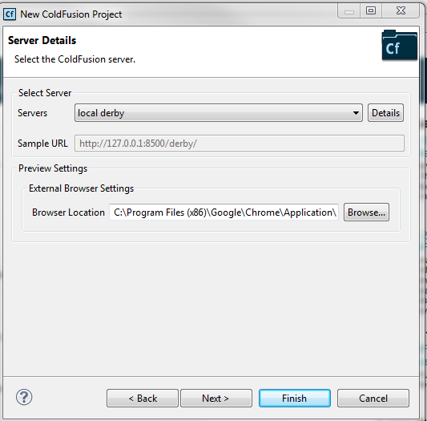

Add coldbox as a linked resource. Check “Use Resource to resolve .cfc’s”

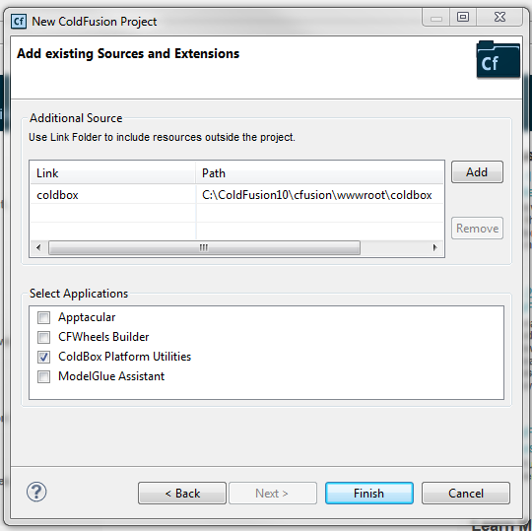

Click Finish. The ColdBox application generator for the new project presents options, select as below.

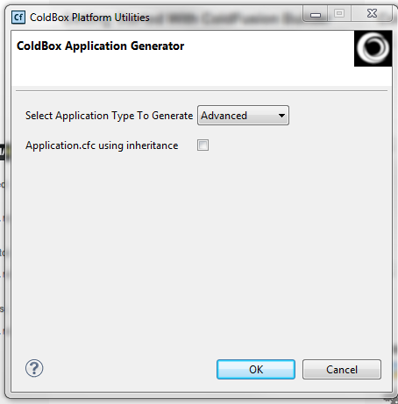

This creates the “derby” project in the /derby subdirectory, and presents the coldbox.cfc configuration file for editing in CF Builder.

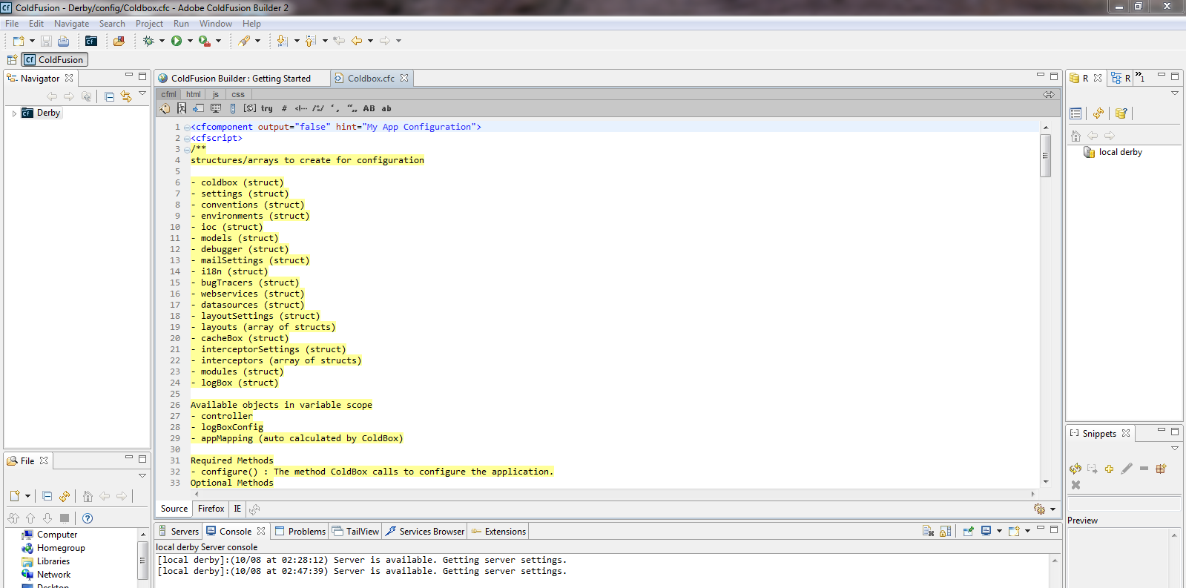

Change the application name to Derby, and browse to the project externally in Chrome. You will see the Application running in ColdBox. The debug screen shows you locations, and tips to get going.

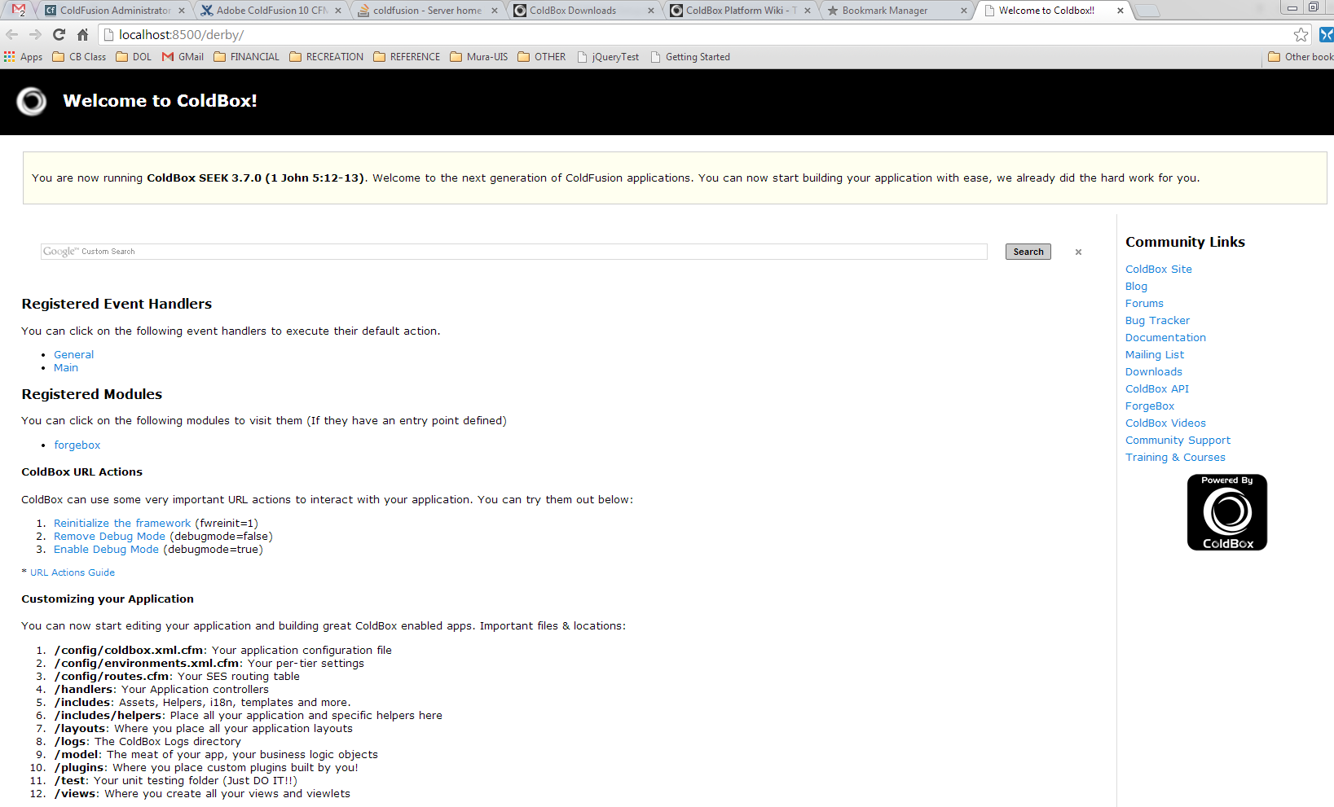

The links are excellent: Here is the URL Actions Guide, which starts you in wiki.coldbox.org.

Check out the search link for “banana”, and see how it is implemented in JS in Derby/views/home.cfm

Copy derby/ to a backup directory, so you can edit here without losing what coldbox has done for you.

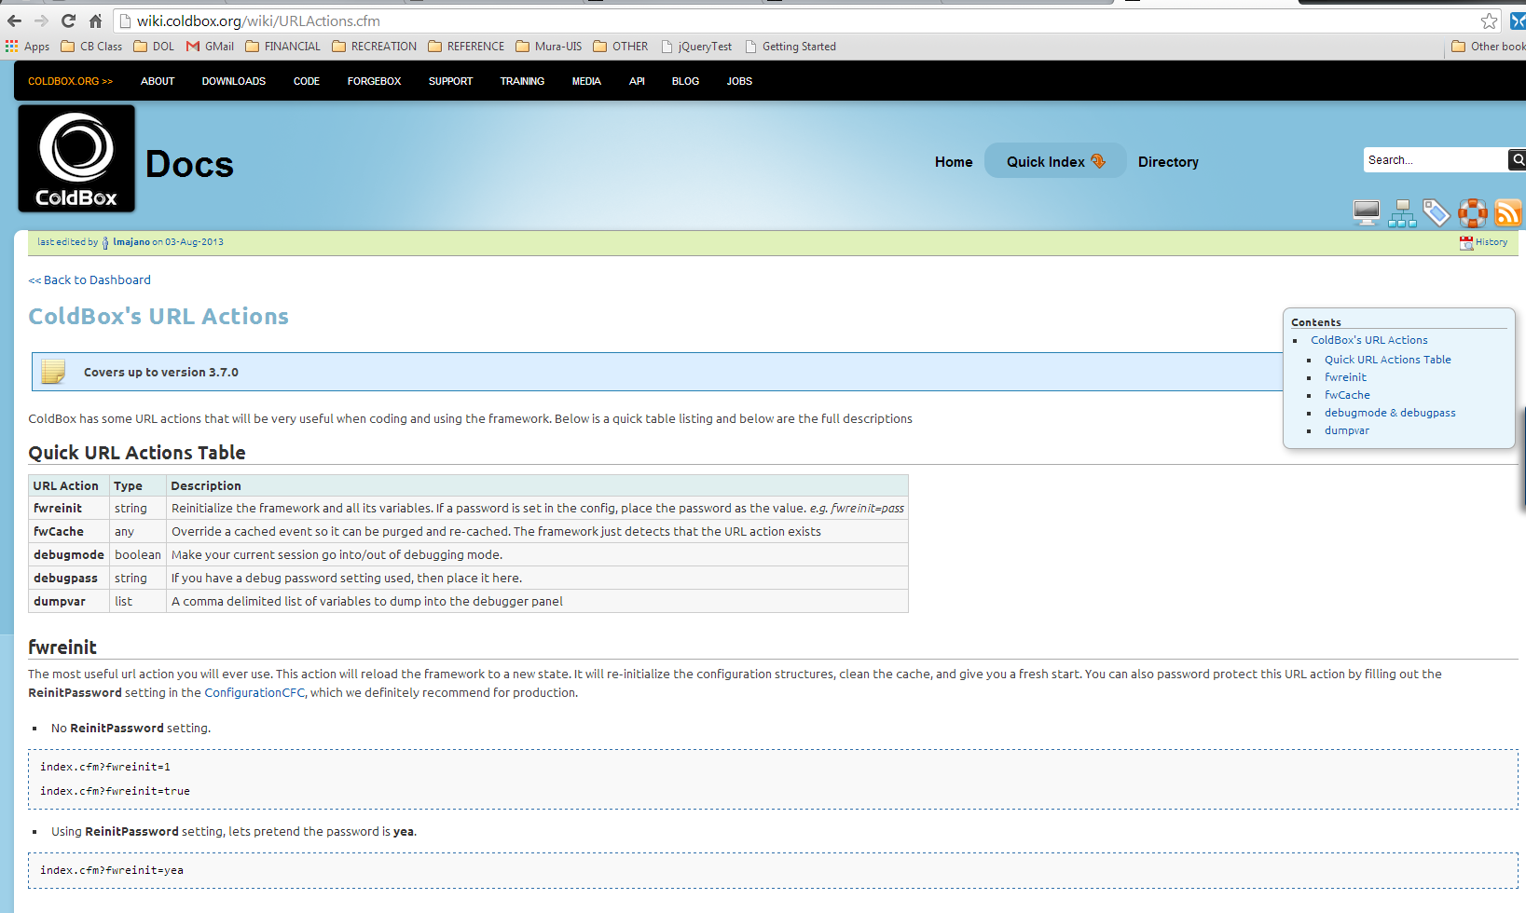

D

D

D

d